Disabled Tech

Win Remote

*Functionality and Demo*

# Functionality

The purpose of winRemote is to allow the end user to create and pass shortcut commands or custom key sequences from their mobile device to a Bluetooth enabled computer. The user would enter the macros and shortcuts they’d like on a desktop GUI this would sync to a database on save. The phone and desktop will then sync over a Bluetooth connection and the phone would be given unique IDs to each command. The phone will take these ID’s and attach the reference to a GUI button the user can press and send the unique ID to the desktop for execution.

[Demonstration Video Here](https://youtu.be/Li0N2zdFWYY)

[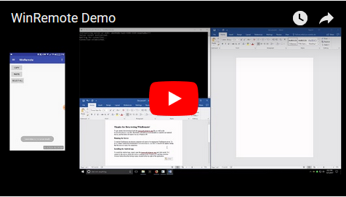](https://youtu.be/Li0N2zdFWYY)

# Poster

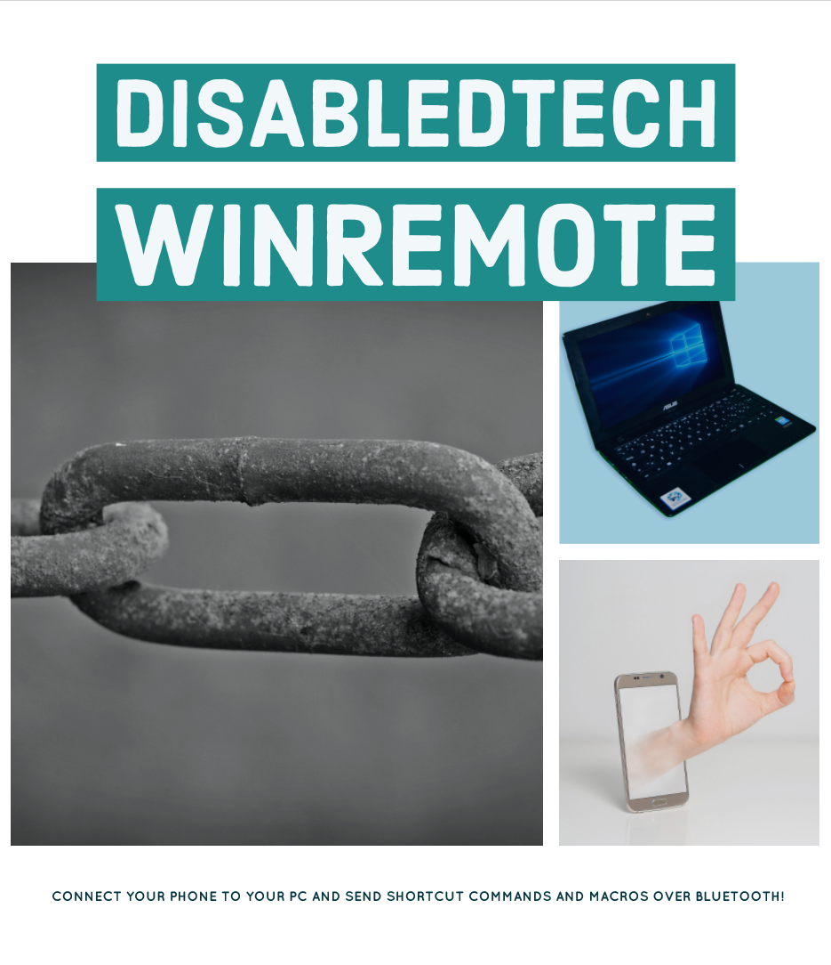

*Features and known Issues*

# Implemented Features

* Server/Client bluetooth connection interface.
* Graceful shutdowns and reconnects on both server and client.
* Data IO via connection on both server and client.
* Server execution framework constructed.
* Dynamic button creation framework constructed.

# Future Features

* Dynamic Android buttons
* UI/UX on Android and Windows
* Button lookup and execution on server
* New button creation on Windows

# Known Issues

* Bluetooth events being sent from queries instantiated outside of our app could potentially result it unclean states.
* Multiple reconnects ends up with duplicate buttons being added.
* Prompting a disconnect with no active connection causes crash.

*Find Installation, Developer, and User Documentation*

# Documents

* <https://github.com/soft-eng-practicum/disabledTech/tree/development_integration/docs>

*Testing*

# User Testing Results

Summary: Many of our users enjoyed our app demonstration and saw its potential even outside the main use case for disabled users. However, all of our testers (with one exception) said that they would either not use our application or were unsure. This seemed to be a combination of the limited applications of the app, as well as the ease of use. Most of our surveyed users cited an “easier and more stable connection” as being the primary reason for this.

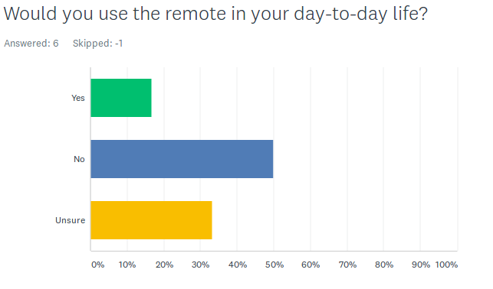

*Environment Setup*

# Setup guidelines

## Setting up Windows server dependencies:

### Prerequisites

Visual Studio 2017 with the .NET desktop development package.

1. First, download the latest 32Feet.NET library from here
2. Run the setup files for the library. It will likely require you to install an older version of the .NET framework in the installer. The library (as of writing) runs on .NET 3.5, while our project is built with a later version. You need both, but they are compatible.
   * warning the installer may give you an error that the MS Help 2.X runtime is not installed. If you care about Help files, you can try to solve that. I don't, so I didn't and it was fine.
3. Afterwards, open the project solution file.

## To set up the database in Visual Studio you will need to:

* right click references > manage NuGET > browse > SQLite.Net-PCL > install
* download sqlite3 dll from http://www.sqlite.org/download.html and copy it into bin/Debug folder

## To work with the Electron Windows GUI:

1. run the following command in the cmd prompt to start the app IF you have node and NPM globally installed.
   1. .\node_modules.bin\electron .
2. However, if neither are installed please look for an online install guide:
   1. <http://blog.teamtreehouse.com/install-node-js-npm-windows>

*Software Usage License and Intellectual Property Terms*

# License

* https://github.com/soft-eng-practicum/disabledTech/blob/development_integration/LICENSE

*Client and Bios*

# Client - Scott Warfield

* Senior Engineer at IBM
* Founder of DisabledTech
* Quadriplegic
* Interest in security, embedded systems development and low-level engineering.

# Aaron Knobloch

* My name is Aaron Knobloch, and I'm a senior software development student, graduating this upcoming May.
* I've taken every relevant course for the 2017 catalog year, aside from QA, and web development. I have a 3.9 GPA with a 4.0 in my major courses.
* Java and Python, am familiar with C/C++ and the basic syntax of a handful of other popular languages.
* I am comfortable with Linux and prefer IntelliJ.
* My interests are in Android development and general full-stack development. I'm familiar with Git and the Gradle build tool.

# Taylor Brust

* Familiar languages/tools: PHP, javascript, HTML, Java, CSS, Bootstrap
* Relevant Classes: QA and Testing, Web Tech/Development, System Analysis and Design, Advanced Programming, intro databases
* Software Dev Major, Senior year
* Mostly using brackets for html/php/css, IntelliJ for QA/java heavy programming

# Jeffrey Graves

* Software Dev Major, Senior
* All required courses for the 2016 GGC catalog excluding testing and software project
* Done a few desktop and mobile apps and a lot of web stuff mostly contract work

# Tobin Michael Crone

* Senior in Software Development - Graduating in 2018
* Advanced Programming, Advanced Databases, Mobile Application Dev., System Analysis and Design
* C#, asp.net, Java, Python, T-SQL, SSIS
* Machine Learning, Neural Networking, AR/VR
* Eclipse, Microsoft Visual Studio, Sql Server Management Studio, Business intelligence development studio, Github (CMD, GUI)